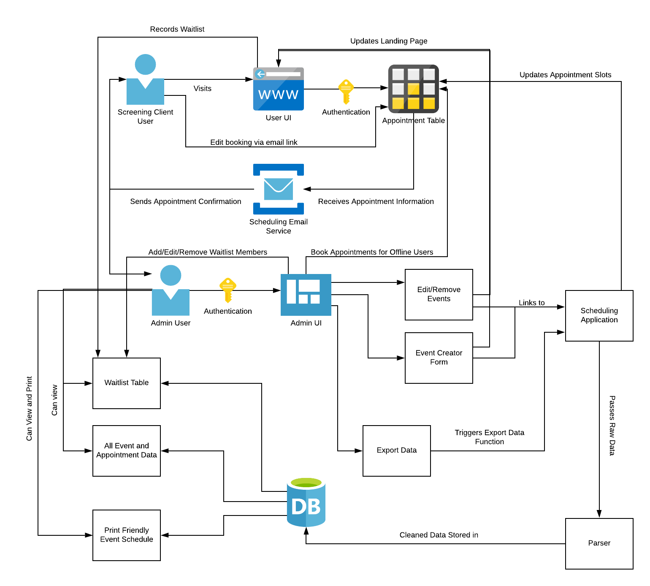

A Detailed System Architecture Diagram describing how users can book appointments, how the admin creates and maintains Screening Events, and how tracked data is accessed.

Starting from the admin, the admin is authenticated in order to reach the admin UI interface. From this interface, the admin can create a new screening event or edit/remove and existing screening event. Each of these options will link to the scheduling application to update the appointment table where the available time slots are stored and will update the general landing page for the user UI which displays the screening events offered. The admin can also book appointments directly for users that may not have or want to book the appointment themselves. The admin can ask for the data for a specific screening to be exported. The export triggers the scheduling application to dump the raw data into a parser and then store it into a database. The admin can then either view the contents of the database, view the waitlist, or view/print an event schedule as needed. Through the admin UI, the admin can also add/edit/remove people from the waitlist table.

The user starts off at the user UI. At the user UI, the user can see a list of all screening events that are offered. Once a screening event is selected, the user is authenticated and redirected to the appointment table where all available time slots for that screening is shown. Once the user selects and confirms an appointment slot, the user receives a confirmation email and all supporting supplemental documents that need to be completed for the screening. The admin is also notified via email about the booking. Once the email is received, the user is able to cancel/edit their booking via a link in that email.

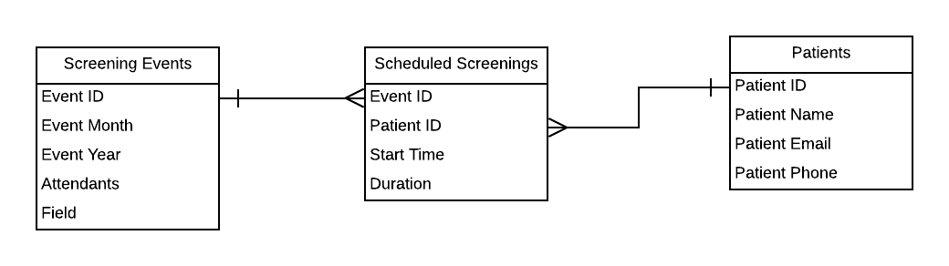

Here is a database model that shows the structure of the database. It has a Patients and Screening Events table that are linked in a many-to-many relationships in the Scheduled Screenings table.